**Banking Customer & Operations Analytics**

## **Executive Summary:**

» **The goal of this banking analytics project is to track customer activity, account usage, loan performance, card usage, and support service.**

»**This will help the bank keep customers, manage risk better, and improve service.**

## **Prepared by:**

|  |  |
| --- | --- |
|  |  |
|  |  |
|  |  |
|  |  |
|  |  |
|  |  |

**Date: May 202**

**Contents**

**Executive Summary:** 1

**Prepared by:** 1

**Data Sources (Sheets/Tables):** 3

**Tables Information :** 3

***Customers*:** 3

**Accounts:** 4

**Transactions:** 4

**Loans:** 4

**Cards:** 4

**Support Calls:** 5

**Data model:** 6

**Data Collection & Methodology:** 6

• Tools Used: 6

• Pre processing steps : 7

**Azure Cloud:** 7

**SQL-Based Data Extraction:** 7

**Data Analysis:** 8

**Loans:** 8

## **Data Sources (Sheets/Tables):**

**1. Customers – Basic customer info and registration date.**

**2. Accounts – Linked to customers with balance and account types.**

**3. Transactions – All financial transactions with types and amounts.**

**4. Loans – Loan records with start/end dates, amounts, and interest rates.**

**5. Cards – Issued cards with types, numbers, and expiration dates.**

**6. Support Calls – Customer service calls including issue type and resolution status.**

### **Tables Information :**

### **Customers:**

|  |  |  |
| --- | --- | --- |
| |  |  | | --- | --- | | **Customer ID** | **A unique identifier for each customer (Primary Key). Used to link this table to other tables like Account, Transaction, or Loan.** | |
| |  |  | | --- | --- | | **FirstName** | **Customer’s first name.** | |
| |  |  | | --- | --- | | **LastName** | **Customer’s last name.** | |
| |  |  | | --- | --- | | **Phone** | **Customer’s phone number for contact purposes.** | |
| |  |  | | --- | --- | | **Email** | **Customer’s email address for digital communication.** | |
| |  |  | | --- | --- | | **Address** | **Customer’s physical mailing address (e.g., for statements or verification).** | |
| |  |  | | --- | --- | | **Join Date** | **The date when the customer registered or started banking with the institution.** | |

### **Accounts:**

|  |
| --- |
| **Account ID:** |
| * **A unique identifier for each account.** |
| * **Primary Key of the Account table.** |
| **Customer ID:** |
| * **A foreign key that links the account to the Customer table.** |
| * **It identifies who owns the account.** |
| **Account Type:** |
| **Specifies the type of account, such as: Checking, Savings , Business** |
| **Balance:** |
| * **The current amount of money in the account (for deposit accounts), or outstanding balance (for loans or credit accounts).** |
| **Created Date:** |
| * **The date the account was opened or created in the bank's system.** |

### **Transactions:**

|  |  |  |  |  |  |  |  |  |  |  |
| --- | --- | --- | --- | --- | --- | --- | --- | --- | --- | --- |
| |  |  | | --- | --- | | **Transaction ID** | **A unique identifier for each transaction (Primary Key).** | | **Account ID** | **A foreign key referencing the Account table — identifies which account the transaction is linked to.** | | **Transaction Type** | **Describes the type of transaction, e.g.:**  **'Deposit' 'Withdrawal' 'Transfer' 'Payment'** | | **Transaction**  **Date** | **The date when the transactions been done** | | **Amount** | **The amount of money used in transactions** | |

### **Loans:**

|  |  |  |
| --- | --- | --- |
| |  |  | | --- | --- | | Loan ID | A unique identifier for each loan (Primary Key). | |
| |  |  | | --- | --- | | Loan Type | Type of loan, such as: 'Home' 'car' 'Personal' 'Education' | |
| **Loan Amount The total principal amount borrowed.** |
| **Interest Rate The annual interest rate applied to the loan** |
| **Loan Start Date The date the loan was issued or disbursed.** |
| **Loan End Date The date by which the loan must be repaid .** |

### **Cards:**

|  |  |
| --- | --- |
| **Card ID** | **A unique identifier for each card (Primary Key).** |
| **Customer ID** | **A foreign key referencing the Customer table — identifies the cardholder.** |
| **Card Type** | **Specifies the type of card, e.g.: 'Debit' 'Credit' 'Prepaid'** |
| **Card Number** | **The card’s number (usually a 16-digit string)** |
| **Issued Date** | **The date the card was issued to the customer** |
| **Expiration Date** | **The date the card expires and needs renewal.** |

### **Support Calls:**

|  |  |
| --- | --- |
| **Call ID** | **A unique identifier for each support call (Primary Key).** |
| **Customer ID** | **A foreign key linking to the Customer table — identifies who made the call.** |
| **Call Date** | **The date and time when the call occurred.** |
| **Issue Type** | **The category or nature of the issue, such as:**  **'Lost Card' , 'Account Access', 'Transaction Dispute' , 'Loan Inquiry '** |
| **Resolved** | **Indicates that issue was resolved. Typically (1/0)** |

### **Data model:**

**All entities in the data model are connected through one-to-many (1 → M) relationships. This structure allows for scalable customer and transaction tracking, enabling detailed performance analysis across loans, accounts, and operations.**

## **Data Collection & Methodology:**

### • Tools Used:

1. **Azure SQL Database 🡪** For secure, scalable cloud-based data storage and management.
2. **SQL Server 🡪** For advanced querying, data transformation, and integration with reporting tools.
3. **Power BI** 🡪 For interactive dashboards, visual analysis, and real-time reporting.
4. **Jupyter Notebook 🡪** Used for machine learning and predictive modeling with Python.

### • Pre processing steps :

* **Data was clean** with no missing or null values.
* **No duplicate records** were found.
* **Data types and formats** were verified for consistency.
* **Ready for analysis** and modeling without additional cleaning steps

## **Azure Cloud:**

## **SQL-Based Data Extraction:**

* **Customer Data Extraction:**
  + **Query🡪** “ SELECT CustomerID, FirstName + ' ' + LastName AS FullName , JoinDate FROM Customers ”.
  + **Purpose🡪**To extract a clean list of customers with their full names and account joindates.
* **Account Data Extraction:**
  + **Query🡪** “ SELECT * from Accounts ”.
  + **Purpose**🡪 To access the full account dataset.
* **Card Data Extraction:**
  + **Query**🡪 “ SELECT * from Cards ”.
  + **Purpose**🡪 To access the full Cards dataset.
* **Transactions Data Extraction:**
  + **Query🡪 “SELECT * from Transactions”.**
  + **Purpose🡪 To access all Transactions dataset.**
* **Lonas Data Extraction:**
  + **Query 🡪**

“ SELECT * , CASE

WHEN LoanEndDate > CAST(GETDATE() AS DATE) THEN 'Active'

ELSE 'No Active'

END AS active_onactive

FROM Loans; ”.

* + **Purpose🡪** To access all Transactions dataset and add new column to classify loans as "Active" or "No Active" by comparing their end date with the current date.

**• Risk Loans Extractions:**

* + **Query**🡪” SELECT * FROM potential_default_risk ”.
  + **Views**🡪”create view potential_default_risk as

SELECT count(L.LoanID) as'countofriskloans'

FROM Loans L

JOIN Customers C ON L.CustomerID = C.CustomerID

JOIN Accounts A ON L.CustomerID = A.CustomerID

LEFT JOIN Transactions T ON A.AccountID = T.AccountID

AND T.TransactionDate >= DATEADD(MONTH, -6, GETDATE())

WHERE T.TransactionID IS NULL AND L.LoanEndDate > GETDATE();”

* + **Purpose🡪** This view helps isolate loan accounts that have had no transactional activity in the last 6 months, despite being still active.

**• Support Calls Data Extraction:**

* + **Query**🡪” SELECT * FROM SupportCalls ”.
  + **Purpose🡪** To access the full Support Calls dataset .

## **Data Analysis:**

### **Loans:**

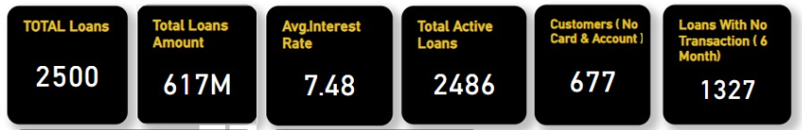**1-Key Metrics & KPIs:**

**Insight:**

* **Total Number of Loans**: 2,500.
* **Total Loan Amount Disbursed**: $617 million.
* **Average Interest Rate**: 7.48%.
* **Active Loans**: 2,486 *( ~ 99.4% of all loans are currently active).*
* **Customers with Loans but No Bank Account or Card**: 677  
  *This represents approximately 27% of the loan customer base.*
* **Loans with No Transactions in the Past 6 Months**: 1,327  
  *Over 53% of loans show no recent activity.*

**Recommendations:**

* **Create bundled offers (e.g., lower interest or cashback) for customers who open checking/saving accounts or apply for cards.**
* **Send periodic notifications or SMS alerts to remind customers about their loan activity, due dates, or available balance**

**2- Distribution Of Loans Amount By Interest Rate?**

**» Loan amounts are grouped into 2% interest rate bins, ranging from 2.5% to 12.5%.**

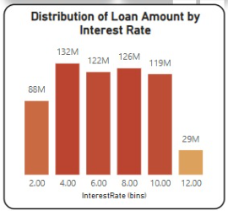**Insights:**

* + **The majority of loans fall within the 4.5%–10.5% interest range (**suggesting that most lending occurs in the mid-rate brackets. A relatively smaller portion is concentrated in the lowest and highest interest segments**).**

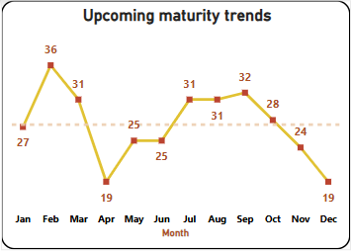**3- Upcoming maturity trends (loans ending this year) ?**

**Insights:**

* **Loan maturities are fairly balanced throughout the year, with February, March, July, August, and September showing slightly higher volumes .**

**Recommendations:**

* **Allocate more staff and support resources during these months to ensure smooth processing and timely follow-ups.**

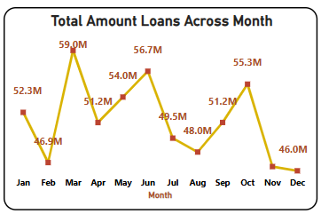**4- Monthly Loan Disbursement Trends?**

**Insights:**

* **The highest loan amounts were given out in March (59M) and October (55.3M),June(56.7M) possibly due to seasonal demand or special offers.**
* **The lowest amounts were in February (46.9M) , November (46.2M) and December(46.0M).**
* **Other months: loan amounts stayed fairly steady with some small ups and downs.**

**Recommendations:**

* **Use this trend to plan marketing campaigns.**

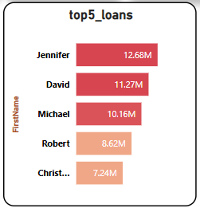**5-Top 5 Loan Holders ?**

**Insights:**

**These five individuals hold a significant portion of the loan portfolio , Monitoring their repayment behavior and engagement can be important for managing risk and maintaining strong customer relationships.**

**Recommendations:**

* **Assign special risk monitoring to top loan holders to ensure repayment and retention.**

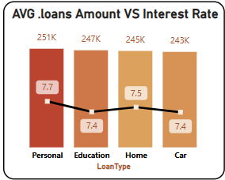**6-Average Loan Amount vs. Interest Rate by Loans Type?**

**Insights:**

* **Personal loans have the highest Interest rates and amounts, while car and education loans offer lower interest rates with slightly smaller average amounts.**

**Recommendations:**

**1-Market these loans to younger customers, families, or students with clear benefits.**

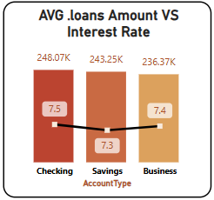**7-Average Loan Amount vs. Interest Rate by Account Type?**

**Insights:**

* **Checking accounts are associated with the highest average loan amount and interest rate.**
* **Business accounts have the lowest average loan amount, with a moderate interest rate.**
* **Saving accounts fall in between.**

**Recommendations:**

**1- Design personalized loan products based on account type behavior.**